**DATA FLOW DIAGRAM:-**

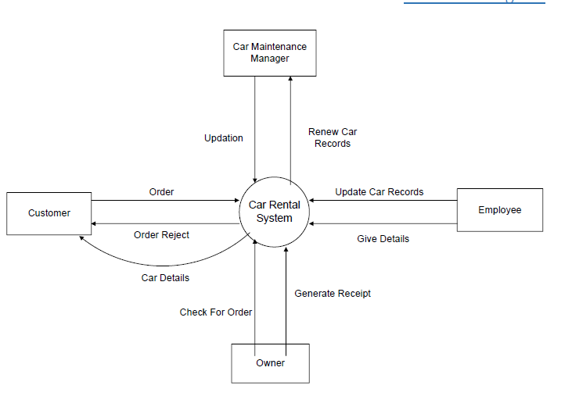

▪ The Customer (a source of information) sends in an order.

▪ The system then sends out an invoice data flow.

▪ Employees update car records and give details to the car rental system.

▪ Car maintenance manager gets information about cars from the system, update the renewed records.

▪ The owner check for order and generates report.

▪ This is a top-level view of the information flow in and out of the system